Hack the box :

Ping

Server pathfinder ping: 10.10.10.30

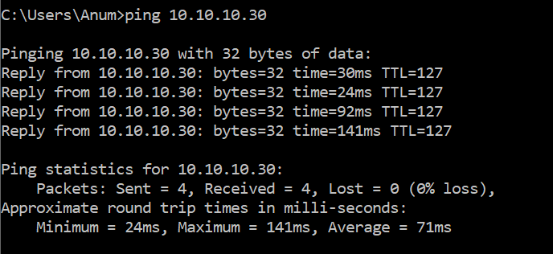

IP address 184.73.185.129

OpenVAS

Name new scan: Full and fast scan :

**2 vulnerabilities:**

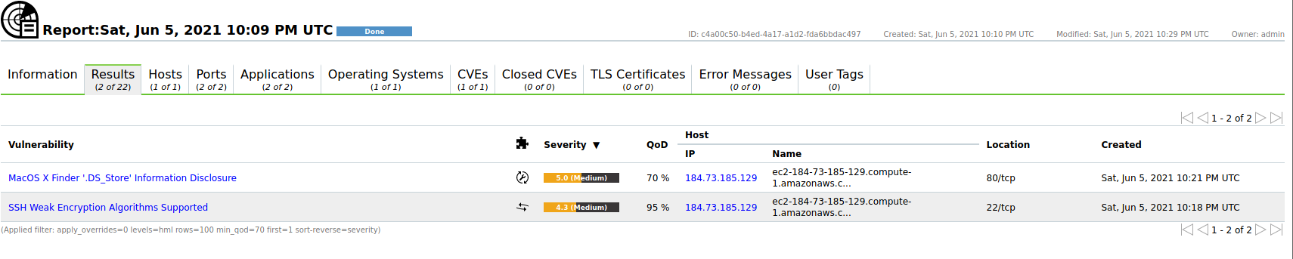

Information disclosure:

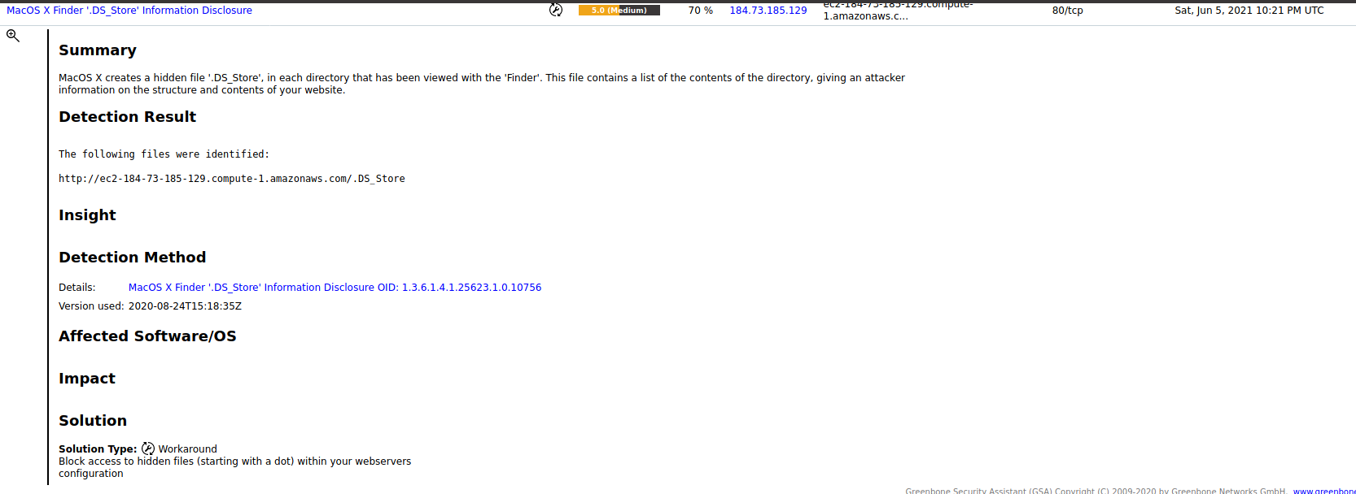

Weak encryption

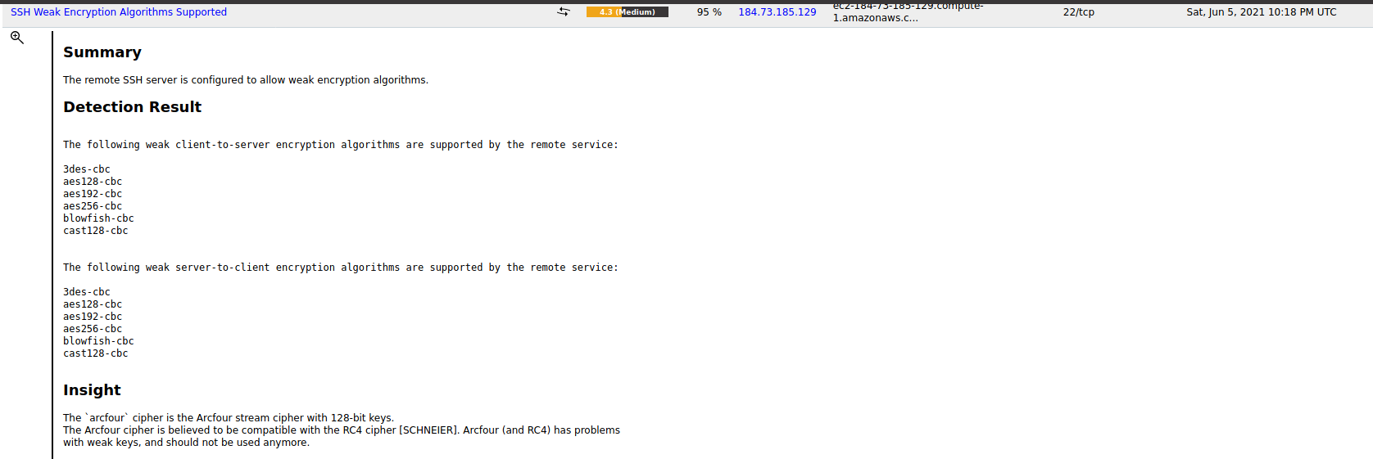

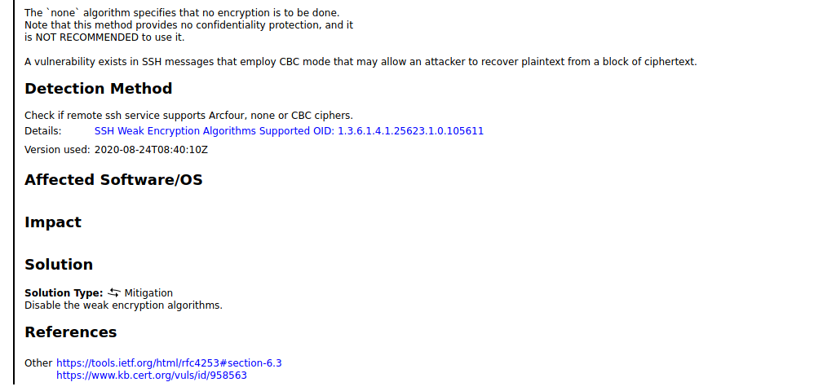

**Hosts:**

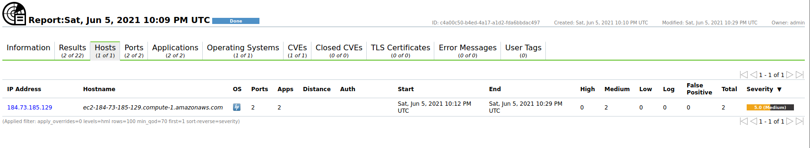

**Ports:**

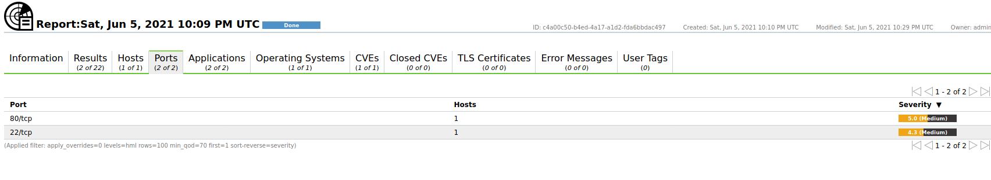

**Applications:**

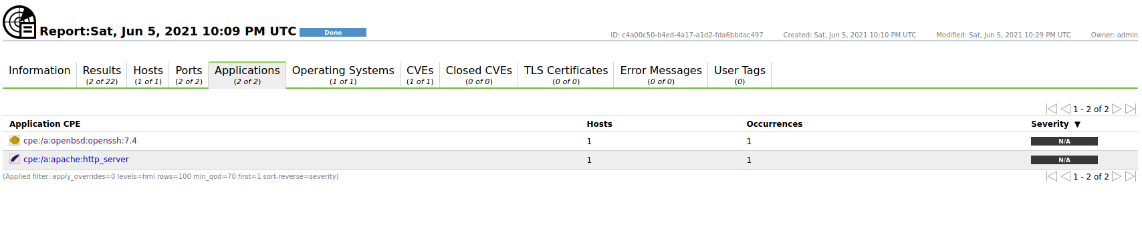

**Operating System:**

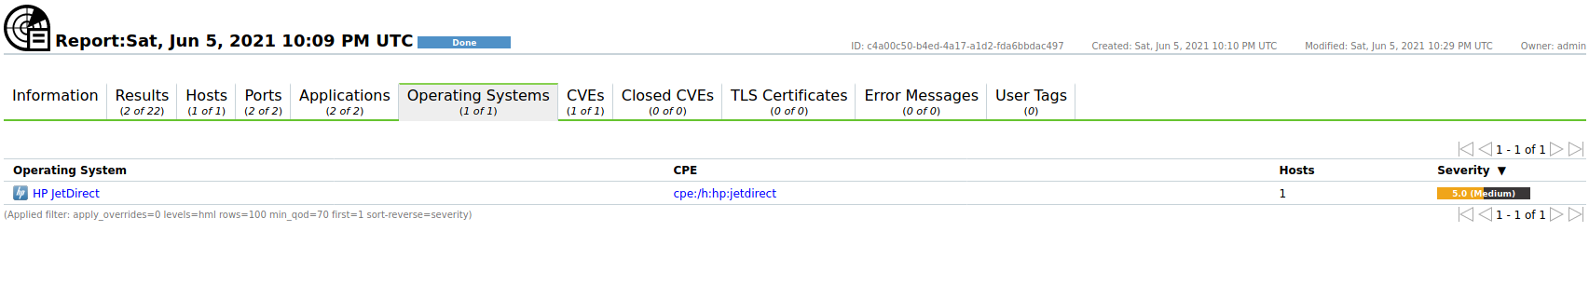

**CVE:**

